AWS SYSTEMS MANAGER
AWS Systems Manager helps you centrally view, manage, and operate nodes at scale in AWS, on-premises, and multicloud environments. With the launch of a unified console experience, Systems Manager consolidates various tools to help you complete common node tasks across AWS accounts and AWS Regions.
AWS Systems Manager is a management and automation service that helps administrators:
- Control EC2 instances remotely
- Automate operational tasks
- Manage patches/configurations
- Store secrets and parameters securely
- Troubleshoot systems without SSH
Use Case
A company has:
- Multiple EC2 Linux servers
- Developers currently use SSH with PEM keys
- Security team wants:
  - No public SSH access
  - Centralized access management
  - Ability to run commands remotely
  - Secure storage for application passwords
Architecture
Admin User

AWS Systems Manager

SSM Agent on EC2

Session Manager Run Command
Launch EC2 Instance
AWS Console → EC2 → Launch Instance
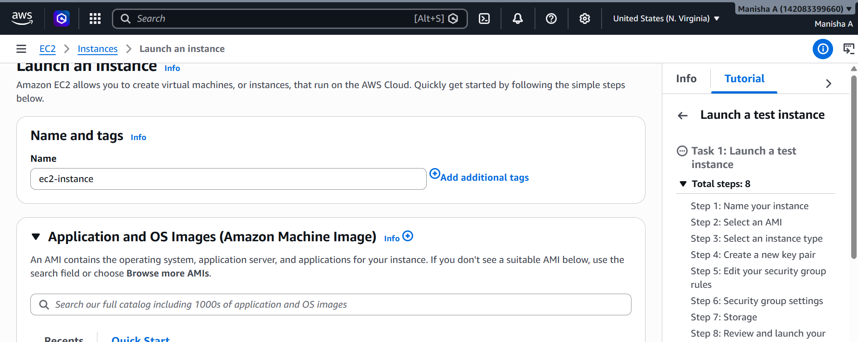
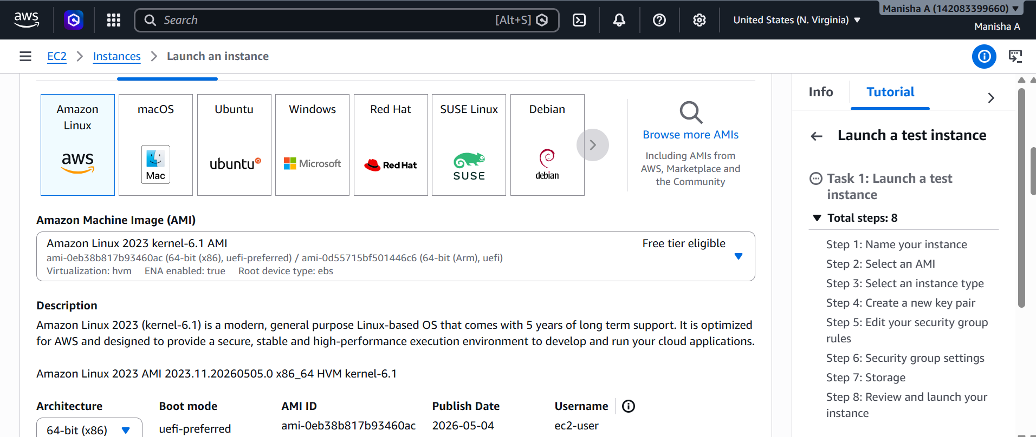
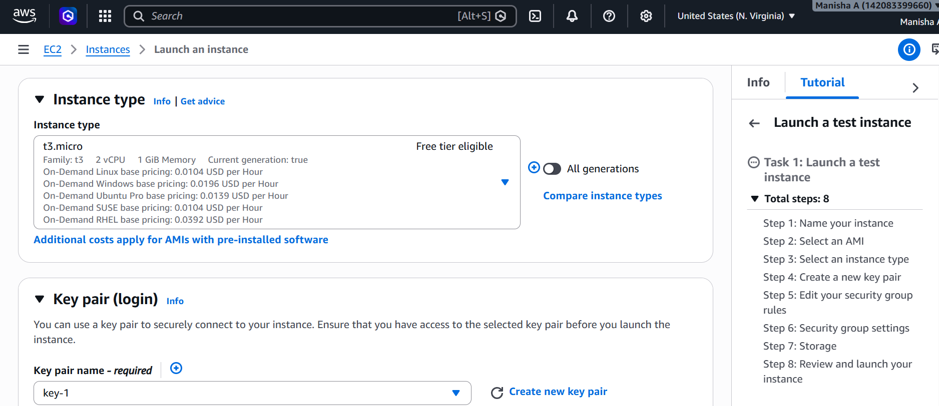
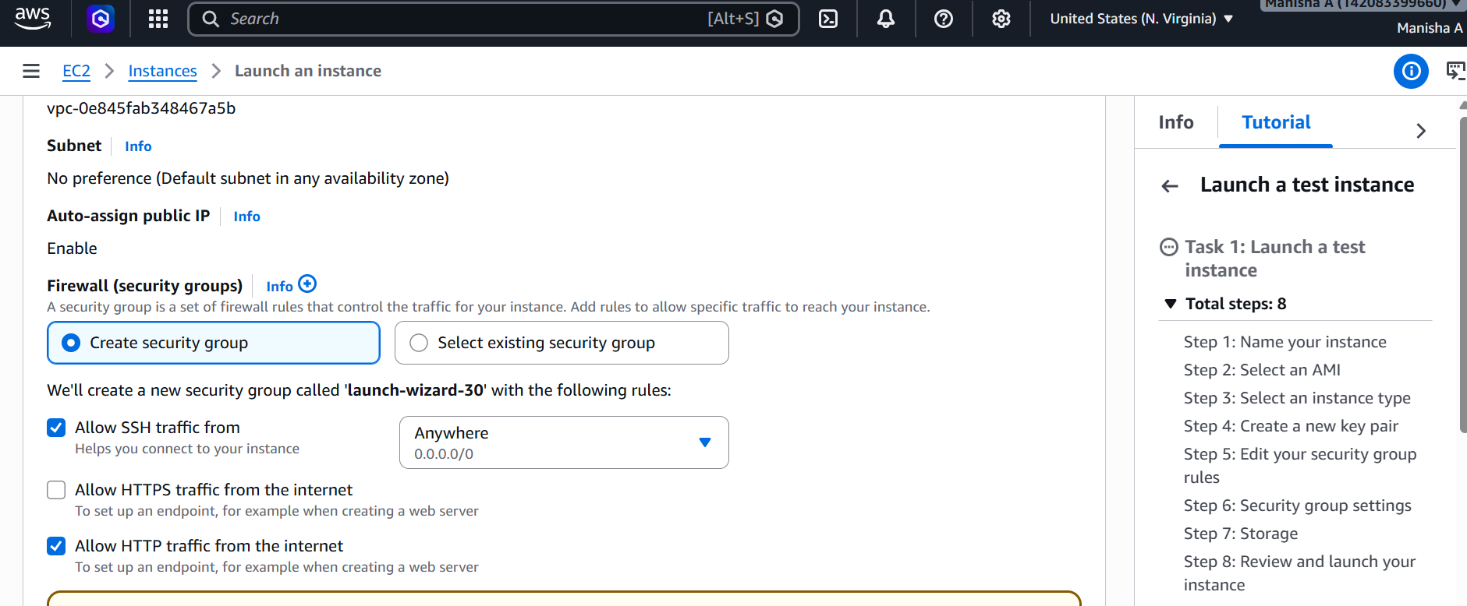
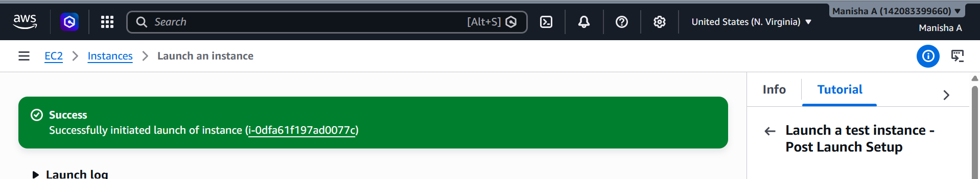
Attach IAM Role for SSM
Create IAM role go to IAM Roles Create Role
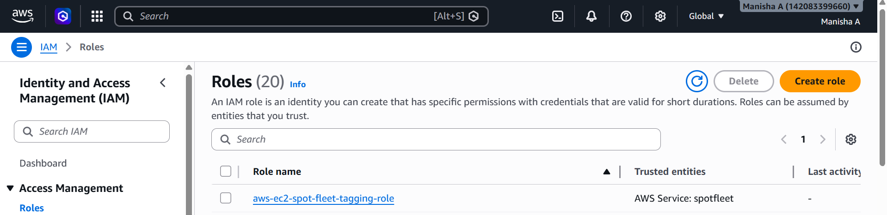
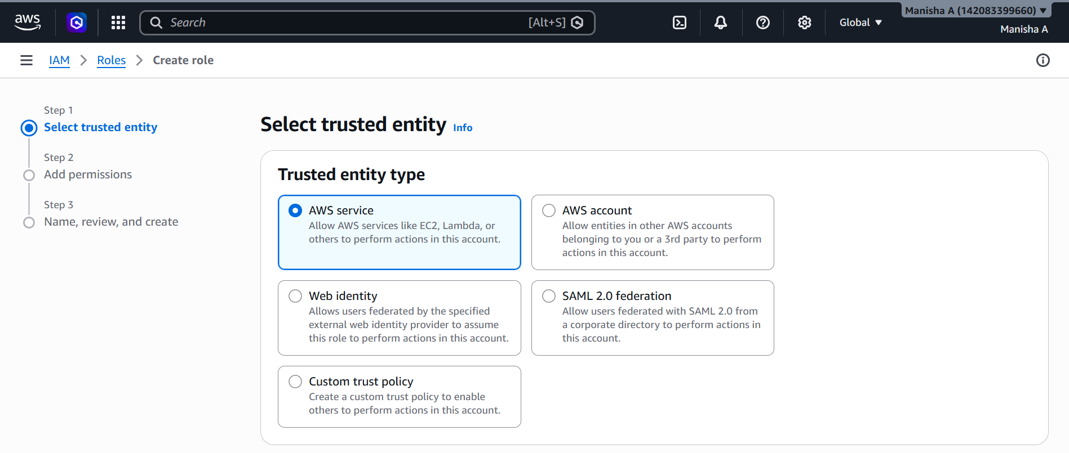
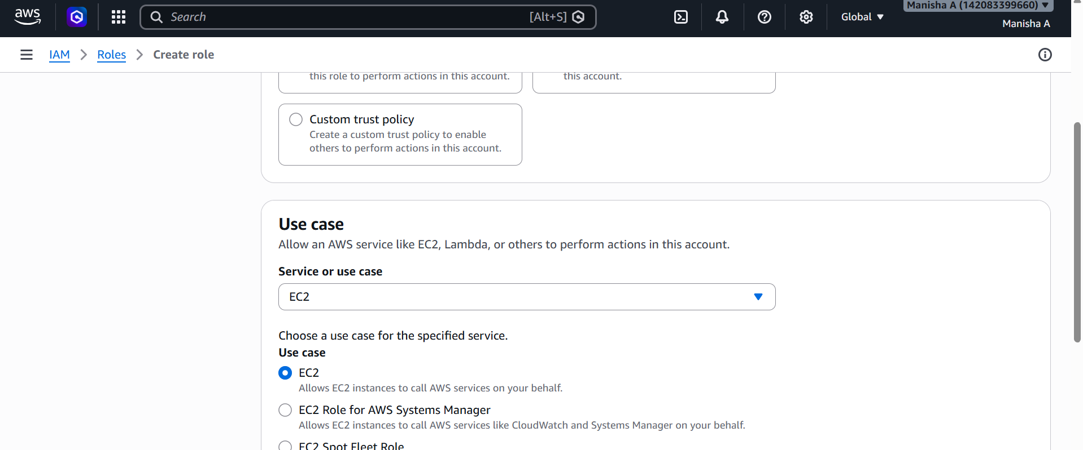
Attach policy
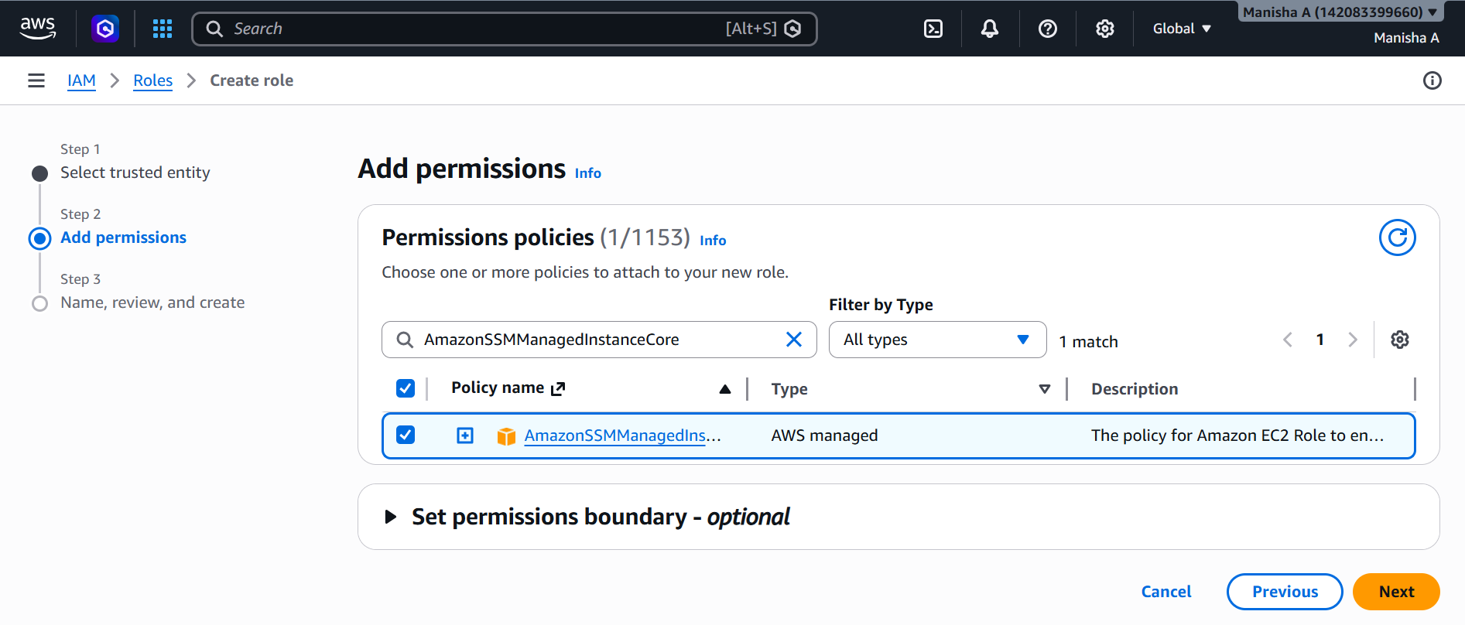
Give the role name
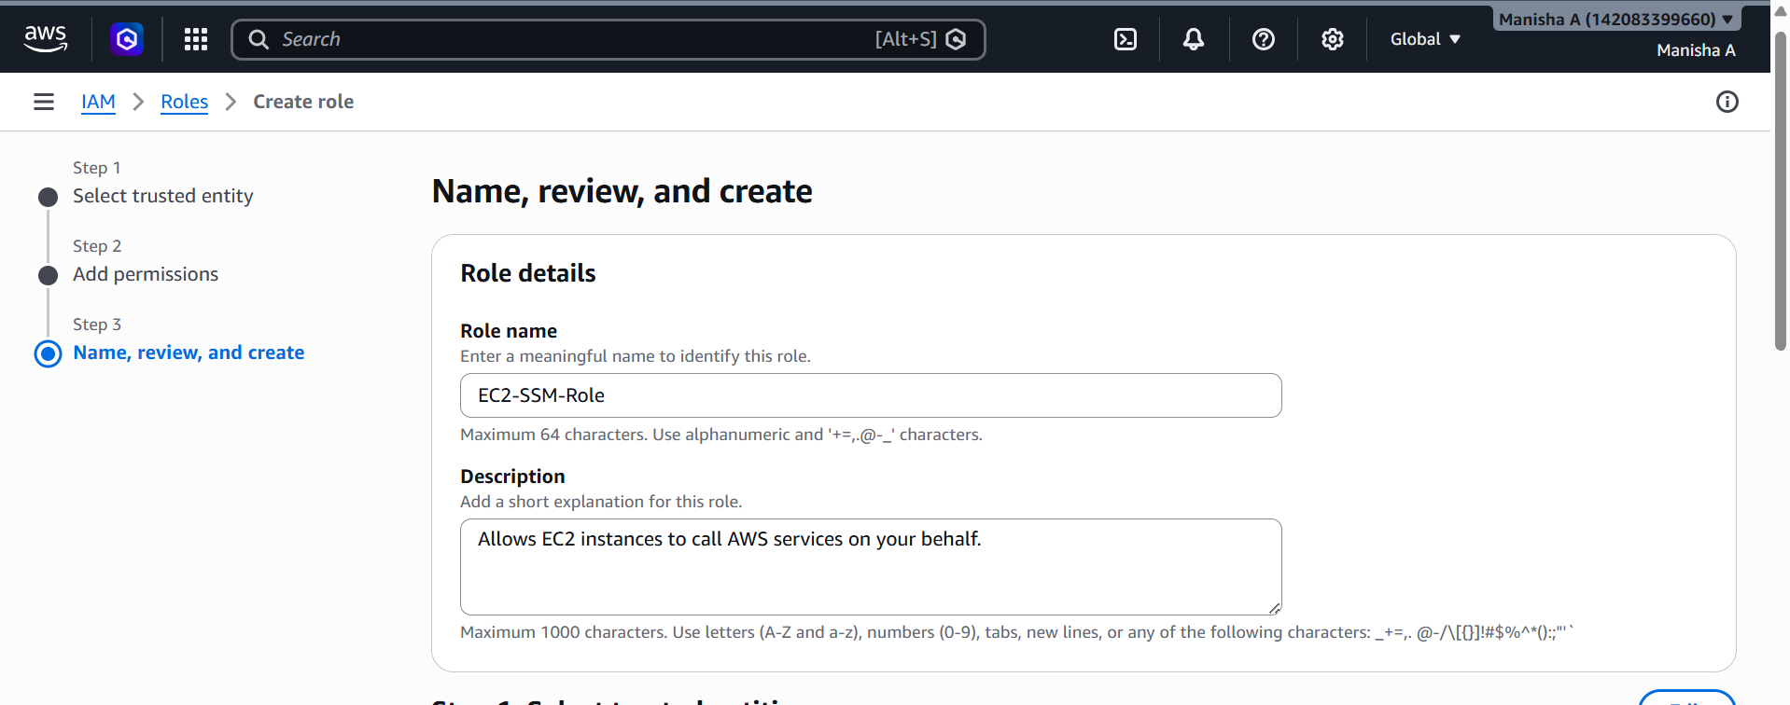
Role created
Verify Managed Instance in SSM
Go to AWS Console → Systems Manager Fleet Manager → Managed Nodes
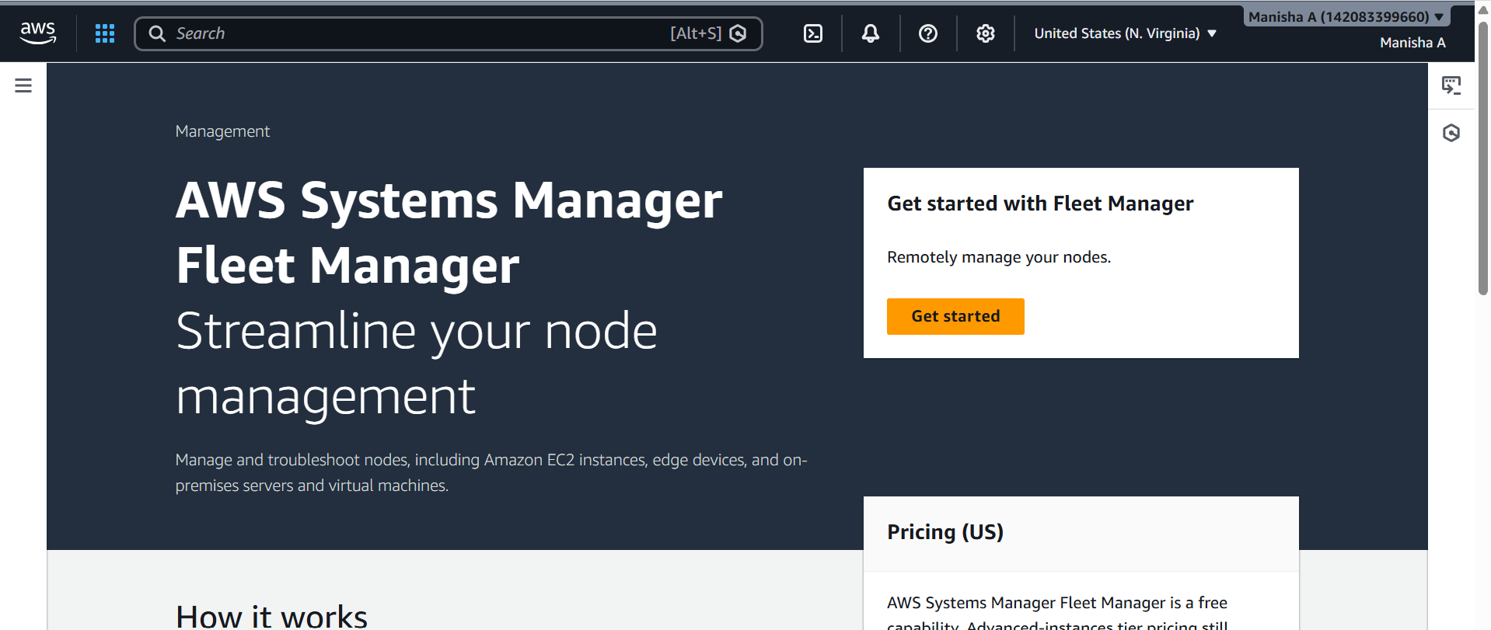
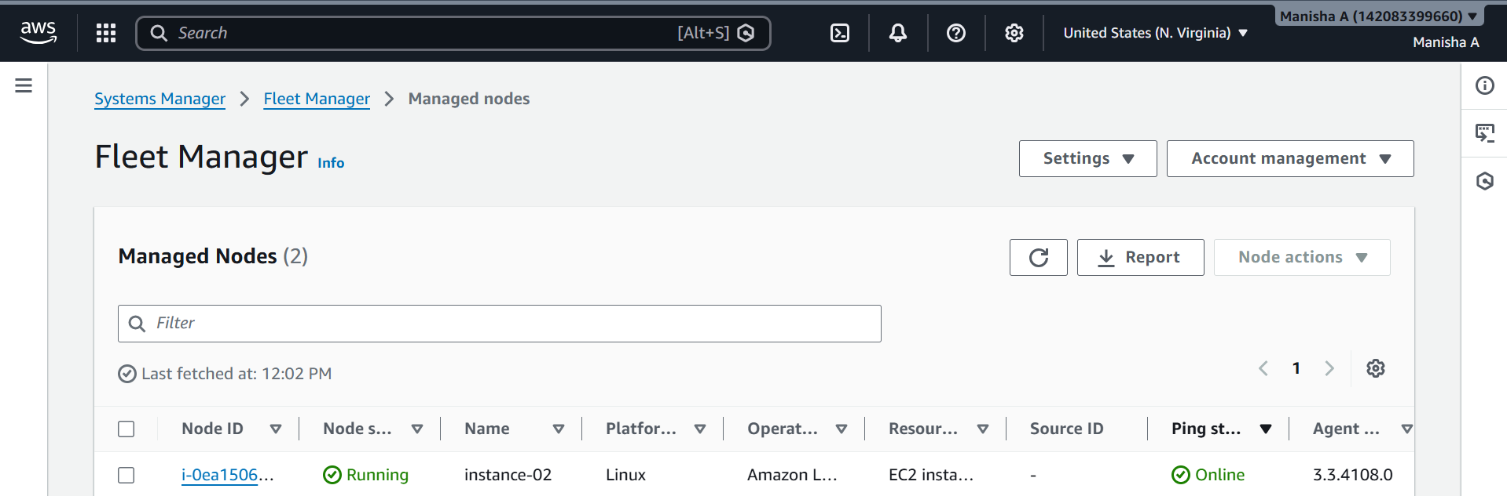
Connected to SSM Manager
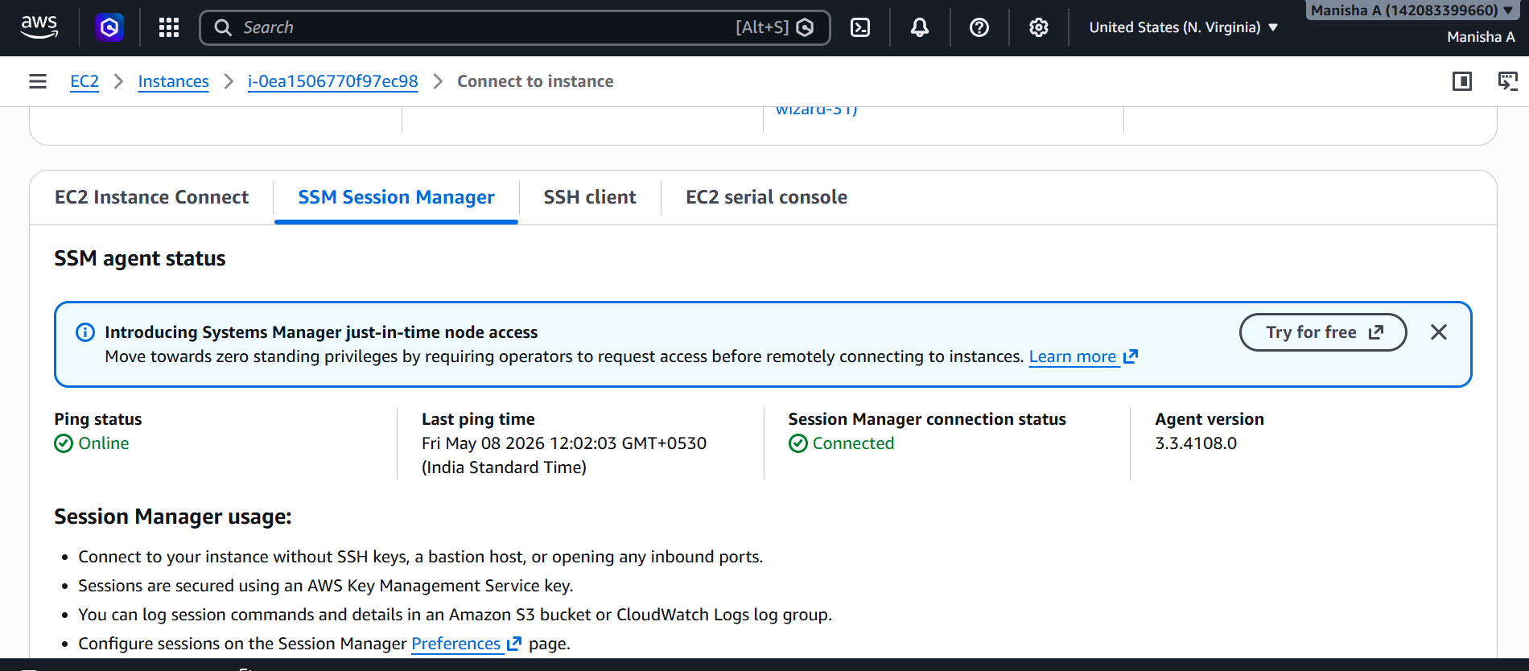
Ran few commands to verify and it is working
